Bubble Sort

Bubble Sort is the simplest sorting algorithm that works by repeatedly swapping the adjacent elements if they are in wrong order.

**Example:**  
**First Pass:**  
( **5** **1** 4 2 8 ) –> ( **1** **5** 4 2 8 ), Here, algorithm compares the first two elements, and swaps since 5 > 1.  
(1 **5** **4** 2 8 ) –>  ( 1 **4** **5** 2 8 ), Swap since 5 > 4  
( 1 4 **5** **2** 8 ) –>  ( 1 4 **2** **5** 8 ), Swap since 5 > 2  
( 1 4 2 **5** **8** ) –> ( 1 4 2 **5** **8** ), Now, since these elements are already in order (8 > 5), algorithm does not swap them.

**Second Pass:**  
( **1** **4** 2 5 8 ) –> ( **1** **4** 2 5 8 )  
( 1 **4** **2** 5 8 ) –> ( 1 **2** **4** 5 8 ), Swap since 4 > 2  
( 1 2 **4** **5** 8 ) –> ( 1 2 **4** **5** 8 )  
( 1 2 4 **5** **8** ) –>  ( 1 2 4 **5** **8** )  
Now, the array is already sorted, but our algorithm does not know if it is completed. The algorithm needs one **whole** pass without **any** swap to know it is sorted.

**Third Pass:**  
( **1** **2** 4 5 8 ) –> ( **1** **2** 4 5 8 )  
( 1 **2** **4** 5 8 ) –> ( 1 **2** **4** 5 8 )  
( 1 2 **4** **5** 8 ) –> ( 1 2 **4** **5** 8 )  
( 1 2 4 **5** **8** ) –> ( 1 2 4 **5** **8** )

|  |
| --- |
| // C++ program for implementation of Bubble sort  #include <bits/stdc++.h>  using namespace std;    void swap(int *xp, int *yp)  {      int temp = *xp;      *xp = *yp;      *yp = temp;  }  // A function to implement bubble sort  void bubbleSort(int arr[], int n)  {      int i, j;      for (i = 0; i < n-1; i++)        // Last i elements are already in place      for (j = 0; j < n-i-1; j++)          if (arr[j] > arr[j+1])              swap(&arr[j], &arr[j+1]);  }    /* Function to print an array */  void printArray(int arr[], int size)  {      int i;      for (i = 0; i < size; i++)          cout << arr[i] << " ";      cout << endl;  }    // Driver code  int main()  {      int arr[] = {64, 34, 25, 12, 22, 11, 90};      int n = sizeof(arr)/sizeof(arr[0]);      bubbleSort(arr, n);      cout<<"Sorted array: \n";      printArray(arr, n);      return 0;  }    // |

Output:

Sorted array:

11 12 22 25 34 64 90

<!—-**Illustration :**  
[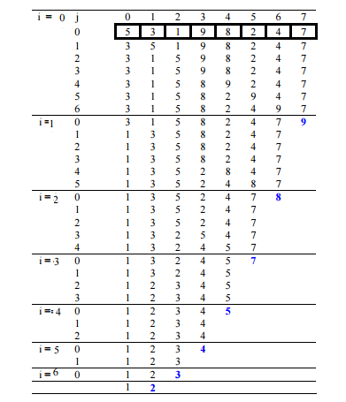](https://media.geeksforgeeks.org/wp-content/cdn-uploads/gq/2014/02/bubble-sort1.png)—>

**Optimized Implementation:**

The above function always runs O(n^2) time even if the array is sorted. It can be optimized by stopping the algorithm if inner loop didn’t cause any swap.

|  |
| --- |
| // Optimized implementation of Bubble sort  #include <stdio.h>    void swap(int *xp, int *yp)  {      int temp = *xp;      *xp = *yp;      *yp = temp;  }    // An optimized version of Bubble Sort  void bubbleSort(int arr[], int n)  {     int i, j;     bool swapped;     for (i = 0; i < n-1; i++)     {       swapped = false;       for (j = 0; j < n-i-1; j++)       {          if (arr[j] > arr[j+1])          {             swap(&arr[j], &arr[j+1]);             swapped = true;          }       }         // IF no two elements were swapped by inner loop, then break       if (swapped == false)          break;     }  }    /* Function to print an array */  void printArray(int arr[], int size)  {      int i;      for (i=0; i < size; i++)          printf("%d ", arr[i]);      printf("n");  }    // Driver program to test above functions  int main()  {      int arr[] = {64, 34, 25, 12, 22, 11, 90};      int n = sizeof(arr)/sizeof(arr[0]);      bubbleSort(arr, n);      printf("Sorted array: \n");      printArray(arr, n);      return 0;  } |

Output:

Sorted array:

11 12 22 25 34 64 90

**Worst and Average Case Time Complexity:**O(n*n).

Worst case occurs when array is reverse sorted.

**Best Case Time Complexity:** O(n). Best case occurs when array is already sorted.

**Auxiliary Space:** O(1)

**Boundary Cases:** Bubble sort takes minimum time (Order of n) when elements are already sorted.

**Sorting In Place:**Yes

**Stable:** Yes

Due to its simplicity, bubble sort is often used to introduce the concept of a sorting algorithm.

* In computer graphics it is popular for its capability to detect a very small error (like swap of just two elements) in almost-sorted arrays and fix it with just linear complexity (2n).
* For example, it is used in a polygon filling algorithm, where bounding lines are sorted by their x coordinate at a specific scan line (a line parallel to x axis) and with incrementing y their order changes (two elements are swapped) only at intersections of two lines.

**Snapshots:**  
[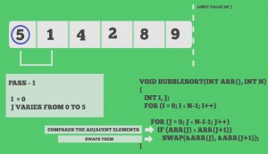](https://media.geeksforgeeks.org/wp-content/cdn-uploads/gq/2014/02/scene00361.jpg)  
[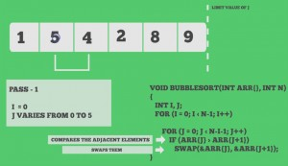](https://media.geeksforgeeks.org/wp-content/cdn-uploads/gq/2014/02/scene00433.jpg)  
[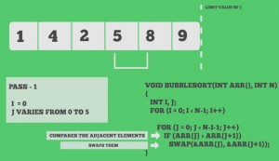](https://media.geeksforgeeks.org/wp-content/cdn-uploads/gq/2014/02/scene00577.jpg)  
[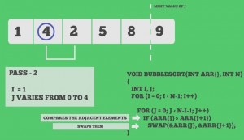](https://media.geeksforgeeks.org/wp-content/cdn-uploads/gq/2014/02/scene00793.jpg)  
[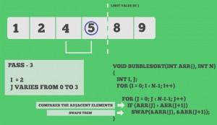](https://media.geeksforgeeks.org/wp-content/cdn-uploads/gq/2014/02/scene01009.jpg)  
[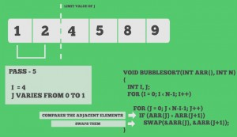](https://media.geeksforgeeks.org/wp-content/cdn-uploads/gq/2014/02/scene01225.jpg)